THE CHRISTIAN JOURNEY

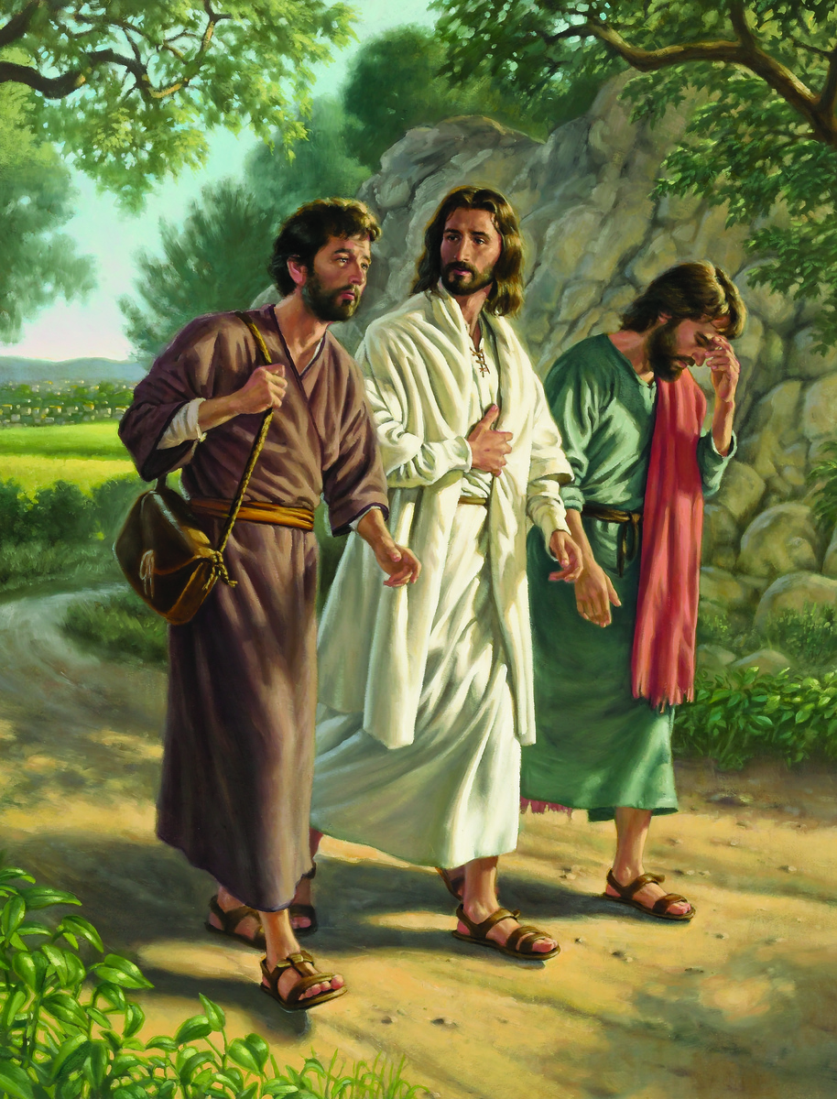

- Whether you are a Christian or not, Life is not easy. Life is full of many heart aches... Divorce, Terminal Illness, Death of a Spouse, Death of a Child, Financial Reversal, Unemployment, Loss of Home, Betrayal, Loss of Sight, Loss of Limb or Limbs (arm and legs) and there are many other unpleasant things that happen to us in life.

- Have you ever wondered why the Christian life is a difficult journey? Most of us have and some of us become discouraged and even think of quitting. What we may not know is that God wants us to grow in our Christian faith and He allows us to be tested. God always sees us through the test of our faith. He rewards us with His blessings when we keep our faith and trust in Him.

- Even if you know Christ as your savior and are a Christian, any of these experiences are very difficult to deal with. Just remember that God will see you through and comfort you during these bad times. The non Christian has a much more difficult time.

- Maybe you do not know Christ as your savior, why not talk with Him right now? He died for you and He knows your every through and action. Believe me if you are sincere and honest you will never regret accepting Him and receiving His gift of eternal life.
Just as sincerely as you know how, pray this simple prayer. God will hear your pray and not turn you away. If you are sincere in a child like faith He will grant you the gift of salvation and a home in Heaven.

Sinner’s prayer for salvation
Lord Jesus, this is my simple prayer to you. I know that I am a sinner and that I often fall short of the glory of God. No longer will I close the door when I hear You knocking. By faith, I gratefully receive Your gift of salvation. I'm ready to trust You as my Lord and Savior. Thank You, Lord Jesus, for coming to Earth. I believe You are the Son of God who died on the cross for my sins and rose from the dead on the third day. Thank You for Your forgiveness of sins and for giving me the gift of eternal life. I invite Jesus to come into my heart and be my Savior. In the name of Jesus, Amen.
When we are feeling stressed and frustrated and wounded by this world, step back and take a look at all of God’s creation. Get outside under the big sky and remind yourself who your God is. Then, get into His word and learn more about God’s love for you. Trust and remember that if he can create and sustain the entire universe, surely He can and will take care of you.

What is The Christian Journey?
- It is journey of learning, growing and knowing God intimately
- It is a process of coming to know ourselves honestly
- It is a journey of God’s forgiveness and healing of our emotional pain and sinful ways of thinking.
- It is a journey of knowing God and His love for us.
- It is a journey of growing emotionally, mentally, and spiritually.
- It is a journey of progressively becoming who we were created to be in God’s original plan for our life.
- It is a journey of getting to know ourselves honestly and knowing God intimately,

The Christian Journey Process
- The Christian Journey is not instant or automatic, throughout history the spiritual journey tends to wind in and through a predictable set of phases.

- The Christian Journey is a spiritual journey where we continually confront twists, turns, and stages. Through the ages the process has been known by a variety of names including spiritual growth, discipleship, spiritual formation/transformation, and sanctification.
The process is the quest for an intimate relationship with our Creator God, Himself.
Along the path our faith is refined, and we learn to deeply trust in God and His love for us.
All of our journeys are similar, and yet all are different.
- Adam and Eve began to live the abundant life in His kingdom and grow in their relationship with God, their Creator Father.

- They had the opportunity to freely choose to bring their life and actions into alignment with God’s plans.

- Their choice brought them to a crisis decision and choice of faith. The result of their decision defined their relationship with God, not only for themselves, but for future generations. Their decision thrust the whole human race into a wilderness-type season.

- Then at the appointed time, Jesus brought for us the opportunity to live the Life of Amazement here on earth and forever in eternity.

There are several biblical examples of the Christian Journey Process.
- Moses made several trips up the mountain of God. It took several rounds through the stages of Awakening to God’s deeper purpose, and Alignment toward God’s plans for Moses.

- Moses experienced many times of testing in the Wilderness, and then emergence into a season of Amazement.

- We can live a life of amazing possibilities in and through our relationship with Christ. We can choose to respond to our Creator God’s loving initiatives and bring our hearts into alignment with His ways. This will be a choice of faith, and our decision will define our relationship with God.

- God is never put off by humanity’s choice of rejection. He will graciously bring His offer of relationship around again.

- When we accept His invitation for relationship and begin to align our lives with His plans, we begin to discover the amazing ancient treasures of Eden and we then find our faith tested in a wilderness.

- All of the twists and turns experienced in the Christian Journey will bring us into a genuine Life of Amazement if we do not give up.

