Matthew 28: 16-17, Corinthians 15:6

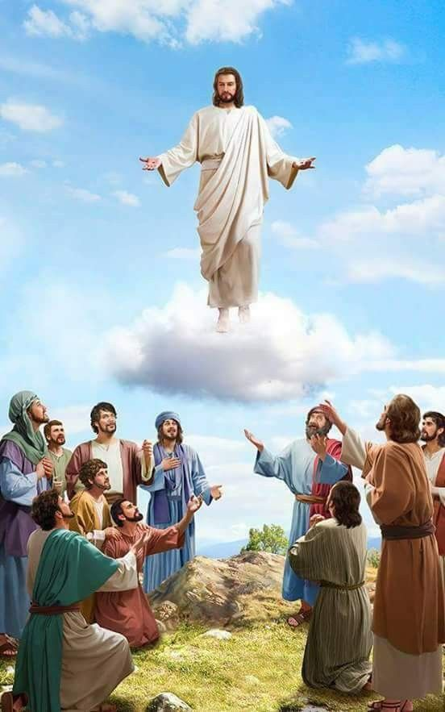

Jesus remained on earth 40 days following His resurrection and appeared before over 500 people before He ascended into Heaven.

Disciples (possibly in Jerusalem) Before Jesus Led Them Out to Mount Olives, Gave Them The Great Commission, and Ascended into Heaven. Luke 24:49-53, Acts 1: 3-11

The Ascension of Christ
- Marks His entry into the supreme authority over creation.
- The ascension marks the departure of Jesus from earth and His interaction with His disciples, and his entry into the realm of God.
- God the Father takes Him up to his right hand in Heaven. Jesus, God incarnate, depended on the Holy Spirit and followed the Father’s will.
- Luke 24: 50-53 Jesus lifts up his hands and blesses his disciples, He blesses them, He is parted from them and He is carried up into Heaven

- Jesus taught the apostles of the coming of the Holy Spirit, and their task as His witnesses. Following this Jesus is lifted up, and a cloud receives Him, and He passes out of the apostles’ sight and He is taken up into Heaven.

Luke 24:49-53 King James Version
⁴⁹ And, behold, I send the promise of my Father upon you: but tarry ye in the city of Jerusalem, until ye be endued with power from on high.
⁵⁰ And he led them out as far as to Bethany, and he lifted up his hands, and blessed them.
⁵¹ And it came to pass, while he blessed them, he was parted from them, and carried up into heaven.
⁵² And they worshipped him, and returned to Jerusalem with great joy:
⁵³ And were continually in the temple, praising and blessing God. Amen.

Acts 1:6-26 King James Version
⁶ When they therefore were come together, they asked of him, saying, Lord, wilt thou at this time restore again the kingdom to Israel?
⁷ And he said unto them, It is not for you to know the times or the seasons, which the Father hath put in his own power.
⁸ But ye shall receive power, after that the Holy Ghost is come upon you: and ye shall be witnesses unto me both in Jerusalem, and in all Judaea, and in Samaria, and unto the uttermost part of the earth.
⁹ And when he had spoken these things, while they beheld, he was taken up; and a cloud received him out of their sight.
¹⁰ And while they looked stedfastly toward heaven as he went up, behold, two men stood by them in white apparel;
¹¹ Which also said, Ye men of Galilee, why stand ye gazing up into heaven? this same Jesus, which is taken up from you into heaven, shall so come in like manner as ye have seen him go into heaven.
¹² Then returned they unto Jerusalem from the mount called Olivet, which is from Jerusalem a sabbath day's journey.
¹³ And when they were come in, they went up into an upper room, where abode both Peter, and James, and John, and Andrew, Philip, and Thomas, Bartholomew, and Matthew, James the son of Alphaeus, and Simon Zelotes, and Judas the brother of James.
¹⁴ These all continued with one accord in prayer and supplication, with the women, and Mary the mother of Jesus, and with his brethren.
¹⁵ And in those days Peter stood up in the midst of the disciples, and said, (the number of names together were about an hundred and twenty,)
¹⁶ Men and brethren, this scripture must needs have been fulfilled, which the Holy Ghost by the mouth of David spake before concerning Judas, which was guide to them that took Jesus.
¹⁷ For he was numbered with us, and had obtained part of this ministry.
¹⁸ Now this man purchased a field with the reward of iniquity; and falling headlong, he burst asunder in the midst, and all his bowels gushed out.
¹⁹ And it was known unto all the dwellers at Jerusalem; insomuch as that field is called in their proper tongue, Aceldama, that is to say, The field of blood.
²⁰ For it is written in the book of Psalms, Let his habitation be desolate, and let no man dwell therein: and his bishoprick let another take.
²¹ Wherefore of these men which have companied with us all the time that the Lord Jesus went in and out among us,
²² Beginning from the baptism of John, unto that same day that he was taken up from us, must one be ordained to be a witness with us of his resurrection.
²³ And they appointed two, Joseph called Barsabas, who was surnamed Justus, and Matthias.
²⁴ And they prayed, and said, Thou, Lord, which knowest the hearts of all men, shew whether of these two thou hast chosen,
²⁵ That he may take part of this ministry and apostleship, from which Judas by transgression fell, that he might go to his own place.
²⁶ And they gave forth their lots; and the lot fell upon Matthias; and he was numbered with the eleven apostles.

